

PROJECT REPORT

**OF**

# MINOR PROJECT

**“RISING STAR SPORTS INSTIUTE WEBSITE”**

## ON

**WEB DESIGNING**

**SUBMITTED IN PARTIAL FULFILLMENT OF THE DEGREE**

**OF**

**BACHELOR OF TECHNOLOGY**

**IN**

## Computer Science and Engineering

##### Submitted By:

##### Name: Ambika Ghosh

##### Roll No.: 12101213

##### DEPARTMENT OF COMPUTER SCIENCE & ENGINEERING

##### PUNJABI UNIVERSITY

##### PATIALA -147002

##### DEPARTMENT OF COMPUTER SCIENCE & ENGINEERING

##### PUNJABI UNIVERSITY, PATIALA

##### CANDIDATE'S DECLARATION

##### I, AMBIKA GHOSH, hereby affirm that the project Report Titled “Rising Star Sports Institute Website”, submitted to Punjabi University, Patiala in partial fulfillment of the requirements for the award to the degree of B.Tech. /B.E. course is my work and that to the best of my knowledge and belief, it contains no written material which to a substantial extent has been accepted for the qualification of any other degree or diploma of a university or other institution of higher learning except where due acknowledgement is made.

##### Signature of Student:

##### Name of Student: AMBIKA GHOSH

##### Roll No: 12101213

##### Regd. No: 7141-2021-612

##### Signature of Examiner

##### i

**ABSTRACT**

The "Rising Star Sports Institute Website" project stands as a testament to the intersection of technology and sports education, utilizing a combination of HTML, CSS, and JavaScript to create a robust and engaging online platform for aspiring athletes. In the contemporary landscape, where digital presence is pivotal for connecting with audiences, the Rising Star Sports Institute recognizes the need for a dynamic website that not only showcases its programs and facilities but also establishes a virtual community for athletes and their families.

The project's objectives are multifaceted, aiming to inform, engage, and streamline user interactions. HTML provides the structural foundation for the website, delineating sections such as the homepage, "About Us," "Programs," "Facilities," "Events," "Gallery," and "Contact." CSS steps in to stylize the layout, ensuring a visually cohesive and professional aesthetic. Meanwhile, JavaScript adds a layer of interactivity, enhancing the user experience by introducing features like dynamic banners, interactive event calendars, and multimedia galleries. The modular design approach ensures scalability and ease of maintenance, facilitating future updates and expansions.

The homepage acts as the digital doorway to the institute, featuring a dynamic banner that highlights current events, achievements, or upcoming programs. Navigation is streamlined through a well-organized menu, directing users to key sections. The "About Us" section provides an immersive overview of the institute, delving into its mission and introducing the coaching staff through engaging visuals and concise narratives. This section serves not only as an informational hub but also as a means of building credibility and trust with the institute's audience. It sets the tone for the user's journey, conveying the ethos and commitment of the Rising Star Sports Institute in nurturing young talents. Moving to the "Programs" section, the project aims to present a detailed and interactive view of the training initiatives offered. Here, HTML structures the content, CSS stylizes the presentation, and JavaScript takes centre stage in facilitating a seamless user experience. Each program is showcased with multimedia content, enriching the user's understanding of the training curriculum and environment. The integration of JavaScript becomes particularly evident in the registration forms, where the language's capabilities are harnessed to streamline the enrollment process. This not only simplifies administrative procedures for the institute but also enhances user engagement, providing a user-friendly avenue for prospective athletes and their parents to express interest and enroll.

**ii**

**ACKNOWLEDGEMENT**

The successful completion of the Rising Star Sports Institute Website project has been a collaborative achievement, and I extend my sincere appreciation to all who contributed significantly to its success. I would like to express profound gratitude to **Dr. Dhavleesh Rattan s**, whose unwavering mentorship and guidance were pivotal throughout the project. His expertise and insights provided invaluable direction, shaping the project's vision and ensuring its alignment with the goals of the Rising Star Sports Institute.

I extend my heartfelt thanks to **Dr. Himanshu Aggarwal**, the Head of the Department, for his support and encouragement. His leadership provided a conducive environment for the project's development. Special appreciation goes to the coaching staff, athletes, and support teams at the institute for their collaboration, enriching the content and functionality of the website. The engagement and support from stakeholders, parents, and the broader sports community have been pivotal, and I look forward to the continued success of the Rising Star Sports Institute Website as a dynamic hub for sports education and community building.

AMBIKA GHOSH

**iii**

**CONTENTS**

**TOPICS Page No.**

Candidate’s Declaration i

Abstract ii

Acknowledgement iii

List of Figures vi

**1 INTRODUCTION 1**

1.1 What is Website? ……………………………………………………………………........................1

1.2 About the Project Website…………………………………………………………………...............1

1.3 Web Designing……………………………………………………………………………………....1

1.4 Features of web designing…………………………………………………………………………..4

1.5 Responsiveness………………………………………………………………………......................5

1.6 Data Validation and Constraints…………………………………………………………………….5

1.7 Software used………………………………………………………………………………………. 6

**2 TRAINING WORK UNDERTAKEN 7**

2.1 Sequential Learning Steps……………………………………………………………………….7

2.2 About sports Website…………………………………………………………………………….8

2.3 Methodology to create the website……………………………………………………………..10

2.4 How Sports Institute works……...……………………………………………………………..12

**3 RESULTS AND DISCUSSION 14**

3.1 Snapshots …………………………………………………………...……………………………...14

**4 CONCLUSION AND FUTURE SCOPE 22**

4.1 Conclusion………………………………………………………………….……………………...22

4.2 Future Scope……………………………………………………………….………………………24

**REFRENCES 25**

#### **LIST OF FIGURES**

**FIGURE NO.Page No.**

**1 INTRODUCTION**

1.1 HTML Format ………………………………………………………………………………………………………….2

1.2 Key Concept of web designing…………………………………………………………………………………5

**2 TRAINING WORK UNDERTAKEN**

2.1 Process of Admission Online……………………….…………………………………………………………..9

2.2 Methodology to create a website…….…………………………………………………………………….11

**3 RESULTS AND DISCUSSION**

3.1 Homepage- Navigation bar view……………………………………………………………………………14

3.2 Homepage-Different Sports Programs…………………………………………………………………..15

3.3 Footer-Homepage…………………………………………………………………………………………………15

3.4 Newspage-Top contianer………………………………………………………………………………………16

3.5 Newspage-Body……………………………………………………………………………………………………16

3.6 Our Champions Card…………………………………………………………………………………………..…17

3.7 Contact Us.……………………………………………………………………………………………………………17

3.8 About us- description………………….………………………………………………………………………..18

3.9 About us- youtube linked videos………………………………………………………………….……….18

3.10 Online Admission Form…………………..……………………………………………………….………...19

3.11 Printed Reciept………………………….………………………………………………………………..………19

3.12 Sports Page…………………….…………………………………………………………………..……………...20

3.13 Community Page-Upcoming Events…..…………………………………………..…………………...20

3.14 Community Page- Team members.……………………………………………...……………………...21

**CHAPTER-1**

**INTRODUCTION**

* 1. **WHAT IS A WEBSITE?**

A website is a digital platform accessible through the internet, comprising interconnected web pages containing various types of content such as text, images, videos, and links. It serves as a virtual space for individuals, businesses, or organizations to share information, promote products or services, engage with visitors, and facilitate online interactions. Websites are built using programming languages like HTML, CSS, and JavaScript, and are hosted on web servers. Users access websites through web browsers, navigating between pages via hyperlinks. Websites vary widely in design, purpose, and functionality, catering to diverse needs, from entertainment and education to e-commerce and communication.

* 1. **ABOUT THE PROJECT WEBSITE**

This project is developed using HTML, CSS, JavaScript. **Rising Star** is a Sports training institute website for information, training in an easy and efficient way. User can view different sports related information, Contact for training with education and users can login with their credentials and print the booking receipt.

* + 1. **TECHNOLOGIES USED IN THE PROJECT**
* Hypertext Markup Language (HTML)
* Cascading Style Sheet (CSS)
* JavaScript (JS)
  1. **WEB DESIGNING**

Web Designing is the process of creating and designing visually appealing and user-friendly websites. It involves a combination of technical skills and creativity to craft the layout, graphics, and overall aesthetics of a website. The primary goal of web designing is to provide an engaging and seamless user experience, ensuring that visitors can easily navigate and interact with the content.

Key elements of web designing include choosing appropriate color schemes, typography,

**1**

and images that align with the website's purpose and target audience. Designers also focus

on responsive web design, ensuring that the website adapts to different screen sizes and devices, enhancing accessibility. Web designers often use various tools and technologies, such as HTML, CSS, JavaScript, and web design software, to bring their creative ideas to life. They collaborate with developers and content creators to integrate design elements with the website's functionality.

**1.3.1 HTML**

HyperText Markup Language (HTML) is a fundamental building block of web designing. It provides the structure and format for web pages, enabling the display of text, images, and multimedia content on browsers. Web designers use HTML tags to define headings, paragraphs, lists, links, and other elements, creating a coherent and organized layout. It forms the backbone of every website, working in conjunction with CSS (Cascading Style Sheets) to control the presentation and appearance. Understanding HTML is essential for web designers to create functional and visually appealing websites that engage users and deliver a seamless browsing experience.

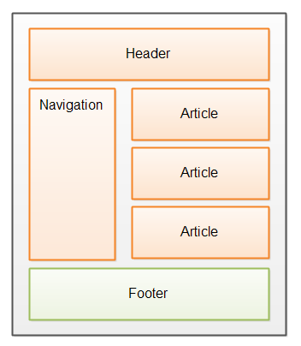

*Figure 1.1 HTML format*

**2**

**1.3.2 CSS**

Cascading Style Sheets (CSS) plays a crucial role in web designing, complementing HTML by controlling the presentation and layout of web pages. It is a stylesheet language that defines how HTML elements should be displayed on a website, including their color, size, font, spacing, and positioning. CSS allows web designers to separate the content (HTML) from its presentation, making it easier to maintain and update the site's appearance across multiple pages.

Using CSS, designers can create visually appealing and consistent designs, ensuring a seamless user experience. By applying styles to HTML elements or groups of elements, they can customize the look and feel of a website to match the brand identity or design preferences.CSS offers various techniques for responsive web design, making websites adapt to different screen sizes and devices. This adaptability is crucial in the mobile-first era, where users access websites from a wide range of devices.

The use of CSS also enhances website accessibility, allowing designers to create more inclusive experiences for users with disabilities. It enables the creation of properly structured documents with semantic tags, improving search engine optimization and making websites more indexable and discoverable. As web browsers evolve, so does CSS. Modern CSS features include animations, transitions, and transformations, enabling designers to add interactivity and dynamic elements to web pages without relying on third-party plugins.

**1.3.3 JavaScript**

JavaScript is a crucial scripting language that revolutionized web designing by adding interactivity and dynamic elements to web pages. As a client-side programming language, JavaScript runs directly in the user's browser, enabling it to interact with the HTML and CSS elements on the page.

Web designers use JavaScript to create engaging user experiences, such as form validation, interactive navigation menus, image sliders, and pop-up notifications. By responding to user actions and events.

With the rise of single-page applications (SPAs) and asynchronous programming

**3**

techniques, JavaScript has become even more essential in modern web design. SPAs provide a fluid and fast user experience by dynamically loading content and updating the page without navigating to new URLs.

Frameworks and libraries like React, Angular, and Vue.js further empower web designers to build complex and interactive web applications. These tools offer pre-built components and simplify the development process, allowing designers to focus on creating innovative and user-friendly interfaces. Moreover, JavaScript is vital for web designers working on responsive design projects.

* 1. **FEATURES OF WEB DESIGNING**

Web designing encompasses various features and elements that collectively contribute to creating visually appealing, user-friendly, and functional websites. Some key features of web designing include:

* **Layout and Structure:** Web designers create a well-organized and intuitive layout that allows users to navigate the site with ease. The arrangement of content, images, and other elements should be visually pleasing and provide a clear hierarchy of information.
* **Color Scheme and Visuals:** Selecting an appropriate color scheme and graphics is
* essential for creating an attractive and cohesive website. Colors can evoke emotions and impact user experience, while visuals like images, icons, and videos enhance engagement.
* **Responsive Design:** In the era of mobile devices, responsive design is a must. Web designers ensure that websites adapt and display correctly on various screen sizes and devices, providing a consistent user experience.
* **Navigation:** An intuitive and user-friendly navigation system is vital for guiding visitors through the website. Clear menus, breadcrumbs, and clickable elements aid in easy exploration of the site's content.
* **Accessibility:** Web designers should adhere to accessibility guidelines to ensure that the website is usable and inclusive for all users, including those with disabilities.
* **Interactive Elements:** Incorporating interactive elements, such as hover effects, animations, and sliders, can enhance user engagement and make the website more captivating.

**4**

Hypertext Markup Language (HTML)

JavaScript

Cascading Style Sheet (CSS)

Web Designing

User Interface

*Figure 1.2 Key Components of Web Designing*

* 1. **What is Responsive Web Design?**

Responsive web design is an approach to web development that aims to create websites that adapt and respond seamlessly to various screen sizes and devices. By using flexible layouts, fluid grids, and media queries, responsive web design ensures that the website's content and design elements automatically adjust to provide an optimal viewing experience on desktops, tablets, smartphones, and other devices. This technique eliminates the need for separate mobile sites and allows users access the same website efficiently, irrespective of the device they are using, providing a consistent and user-friendly experience**.**

* 1. **Data Validations and Constraints:**
* **Required Data Fields:** There are many fields in many forms in which user have to put some data. If you just not give any entry or text in some kinds of the fields then it won’t allow because of that, our data is stored very neatly.
* **No Alphabets Allowed:** There are many fields in the application which user won’t be allowed to store any kind of alphabets, Like the Phone number field.

**5**

* **No Digits Allowed:** There are many fields in the application which user won’t be allowed to store the digits in some fields. Like many forms having the field like names, in which user won’t be allowed to store any digits in that given fields.
* **User Validation:** There is validation of username, we are just validating the username. If similar kind of user is found in the database, then application won’t allow the same name of username.
* **Password Validation:** Whenever user wants to change the password them, he/she must have entered the password.
* **Email Validation:** Whenever an application will ask for email, then user must have to enter the email in correct format.
* **Mobile Number Validation:** Whenever user enters the phone number, it must have 10 digits.
  1. **SOFTWARE USED**

There are various software and tools that can be used to build **SPORTS WEBSITE**. Here are some of the commonly used ones:

* **Text Editors / Integrated Development Environments (IDEs):** Software tools like Visual Studio Code, Sublime Text, Atom, and JetBrains WebStorm are commonly used by developers to write and edit code efficiently.
* **Front-End Frameworks and Libraries:** Frameworks like React.js, Angular, Vue.js, and libraries like jQuery, Bootstrap, and Material-UI are used to streamline front-end development, create reusable components, and enhance user interfaces.
* **Version Control Systems:** Tools like Git, SVN (Subversion), and Mercurial are used to manage changes to the codebase, track versions, and facilitate collaboration among team members.
* **Browser Developer Tools:** Developer tools available in web browsers, such as Chrome DevTools, Firefox Developer Tools, and Safari Web Inspector, help debug, profile, and optimize front-end code and performance.
* **Development tools:** Code editors like Visual Studio Code or Atom, version control systems like Git, and project management tools like Trello or Asana can be used to manage the development process.
* **Responsive Design Tools:** Tools like Adobe XD, Sketch, and Figma aid in designing responsive layouts and prototypes for web apps.

**6**

**CHAPTER- 2**

**WORK UNDERTAKEN**

**2.1 SEQUENTIAL LEARNING STEPS**

Web designing involves creating the visual and interactive elements of a website. Here are the sequential steps you can follow for web designing using HTML, CSS, and JavaScript:

* **Planning and Research:**
* Define the purpose of the website and the target audience.
* Research similar websites for inspiration and to understand design trends.
* Create a sitemap to outline the structure and navigation of the website.
* **Wireframing and Mockups:**
* Sketch a basic layout of the website using pen and paper or digital tools.
* Create a more detailed wireframe using software like Adobe XD, Sketch, or Figma.
* Design mockups for different screen sizes (desktop, tablet, mobile).
* **HTML Structure:**
* Begin by creating the basic HTML structure using tags like <html>, <head>, and <body>.
* Divide the content into sections using semantic HTML elements like <header>, <nav>, <main>, <section>, <article>, <footer>, etc.
* **CSS Styling:**
* Link an external CSS stylesheet to your HTML document using the <link> tag.
* Apply styles to HTML elements using CSS properties like color, font-family, margin, padding, etc.
* Use classes and IDs to target specific elements for styling.

**7**

* **Layout and Positioning:**
* Implement responsive design using CSS media queries to adapt the layout for different screen sizes.
* Utilize CSS Flexbox or CSS Grid for creating layouts and positioning elements.
* **Interactive Elements with JavaScript:**
* Integrate JavaScript for interactivity and dynamic behavior.
* Add event listeners to elements, like buttons and forms, to trigger actions.
* Use JavaScript to create animations, sliders, and other interactive features.
* **Responsive Web Design:**
* Deepen your understanding of responsive design principles, including fluid grids, flexible media, and breakpoints.
* Implement media queries and CSS techniques to create websites that work well on various devices.
* **Introduction to Frameworks and Libraries:**
* Familiarize yourself with popular front-end libraries and frameworks like React, Vue.js, or Angular for building more complex web applications.

**2.2 ABOUT SPORTS INSTITUTE WEBSITE**

The Rising Star Sports Institute Website emerges as a transformative online platform, reshaping the landscape of sports education and connectivity within the community. In the digital age, where online presence is pivotal, the website plays a crucial role in providing comprehensive information, fostering interaction, and building a dynamic sports community. A conceptual analysis of the website reveals key contextual aspects that shape the user experience and influence aspiring athletes and their families.

**2.2.1 Technological Integration:**

Harnessing technological advancements such as HTML, CSS, and JavaScript, the website ensures a seamless and accessible experience for users the Rising Star Sports Institute's website utilizes these technologies for a user-friendly interface and interactive features. The integration of secure online registration forms and dynamic content presentation reflects the influence of technological progress on how information is delivered and accessed in the sports education sector.

**8**

**2.2.2 Global Connectivity:**

Similar to the global reach facilitated by digital platforms in various industries, the Rising Star Sports Institute's platform transcends geographical boundaries. Aspiring athletes and their families can easily explore training programs, facilities, and events from anywhere in the world, fostering a global community of sports enthusiasts. This reflects the contemporary trend of digital platforms providing information and connectivity beyond physical limitations.

**2.2.3 Community Engagement and Competition:**

Within the competitive landscape of sports education, the website acknowledges the widespread interest in sports and adventure. It strategically positions itself amid this competition by emphasizing not only the programs it offers but also the community it fosters. Aspiring athletes seek an institute that not only provides quality training but also cultivates a supportive and engaging environment. This mirrors the preferences of users in various sectors who gravitate towards platforms offering not just products or services but also a sense of community.

**2.2.4 Trust and Security:**

Security and trust are paramount considerations for users engaging with the Rising Star Sports Institute Website. Drawing parallels with other industries' emphasis on secure payment gateways and data privacy, the website employs SSL certificates and secure online forms to instill confidence in its users. The commitment to safeguarding personal and financial information during the enrollment and registration processes reflects an understanding of the importance users place on a secure and trustworthy online platform.

*Figure 2.1 Process of Admission Online*

**9**

**2.3 METHODOLOGY TO CREATE THE WEBSITE**

The methodology for developing the Rising Star Sports Institute Website follows a systematic approach to ensure the effective design, development, and implementation of the platform. Here's a parallel breakdown of the methodology tailored to the sports institute context:

**2.3.1 Requirement Analysis:**

Identify requirements specific to sports education, including dynamic homepage features highlighting programs and achievements, interactive event calendars, athlete profiles, user-friendly admission processes, and responsive design for optimal user experience.

**2.3.2 System Design:**

Structure HTML, CSS, and JavaScript components to define content, layout, and interactive features. HTML organizes program details, CSS ensures a visually cohesive design, and JavaScript facilitates dynamic elements like registration forms. The design focuses on seamless navigation and responsiveness.

**2.3.3 User Interface Design:**

Prioritize intuitive navigation through clear menus and buttons, aligning with the sports institute's unique needs. CSS maintains consistent branding, typography, and layouts. JavaScript enhances user interaction, facilitating dynamic content updates and ensuring an engaging sports-focused experience.

**2.3.4 Development:**

Implement the project based on the system design, focusing on core functionalities such as athlete profiles, program details, and interactive forms for admission. HTML, CSS, and JavaScript work collaboratively to create a cohesive and interactive sports education platform.

**2.3.5 Testing:**

Conduct rigorous testing, including unit testing, integration testing, and user acceptance testing, to identify and address any issues or bugs specific to the sports institute context. Ensure that the website functions correctly and meets the unique requirements of sports education.

**10**

**2.3.6 Deployment:**

Deploy the Rising Star Sports Institute Website on a server, making it accessible to users. Implement security measures, including user authentication and service-based controls, to safeguard sensitive information related to athletes and programs.

**2.3.7 Maintenance and Support:**

Provide ongoing maintenance and support to address any issues and incorporate enhancements post-deployment. Gather feedback from athletes, coaches, and stakeholders to identify areas for improvement and future developments in line with the evolving needs of sports education.

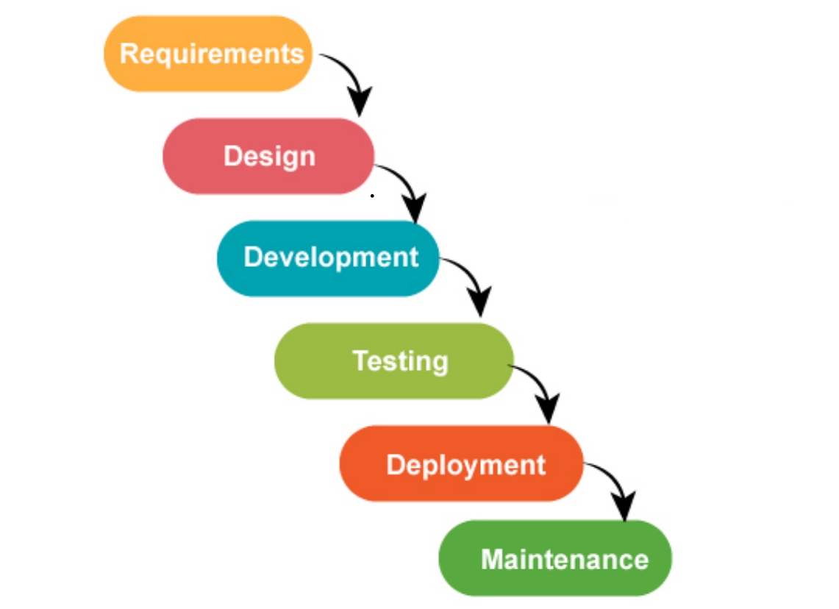

*Figure 2.2 Methodology to create a website.*

**11**

**2.4 How Sports Institute Website works?**

Through a combination of engaging visuals and user-friendly forms, the website aims to provide a holistic and inspiring experience for both prospective athletes and the broader sports community.

* **Home:**

Dynamic Banner: Features current events, achievements, or upcoming programs.

Navigation: Well-organized menu directs users to key sections.

Engaging Interface: Captures attention and serves as the virtual entrance to the institute.

* **Admission:**

Information Hub: Details on training programs, schedules, and enrollment procedures.

Registration Forms: Interactive JavaScript forms streamline the enrollment process.

Multimedia Content: Showcases program highlights through images and videos.

* **Our Champions:**

Success Stories: Profiles and achievements of past and current athletes.

Multimedia Gallery: Visual representation of the institute's success and vibrant sports culture.

Inspirational Content: Highlights the journeys of athletes who have excelled.

* **About Us:**

Institute Overview: In-depth information about the institute's mission and values.

Coaching Staff: Engaging visuals and concise descriptions introduce the experienced team.

Ethos Narration: Establishes trust and credibility, setting the tone for the user experience.

* **Contact Us:**

Inquiry Form: User-friendly form for inquiries and feedback.

Contact Information: Provides various contact channels for user convenience.

Map Integration: Helps users locate the institute's physical presence.

**12**

* **News:**

Event Updates: Announcements about upcoming tournaments, workshops, and activities.

Articles and Highlights: Informative content related to sports and institute news.

* **Sports Page:**

Comprehensive Information: Details about various sports programs offered.

Multimedia Elements: Incorporates images and videos showcasing the different sports.

Event Calendar: Interactive JavaScript calendar for sports-related events and competitions.

**13**

**CHAPTER – 3**

**RESULTS AND DISCUSSION**

The **Rising Star Sports Institute** Website provides a seamless and user-friendly experience, resembling the convenience of a travel booking platform. The homepage introduces users to dynamic banners highlighting institute events, with intuitive navigation to sections like admissions, success stories, and news. Offering a hassle-free enrollment process with a user-friendly form, the website showcases athletes' achievements through multimedia in a manner reminiscent of travel destinations. The About Us section establishes trust through engaging visuals and coaching staff introductions, while Contact Us ensures easy user interaction. Regular updates maintain the site's dynamism, creating an inspiring and engaging virtual space for aspiring athletes and sports enthusiasts.

**3.1 SNAPSHOTS OF WEBSITE**

**3.1.1 Homepage**

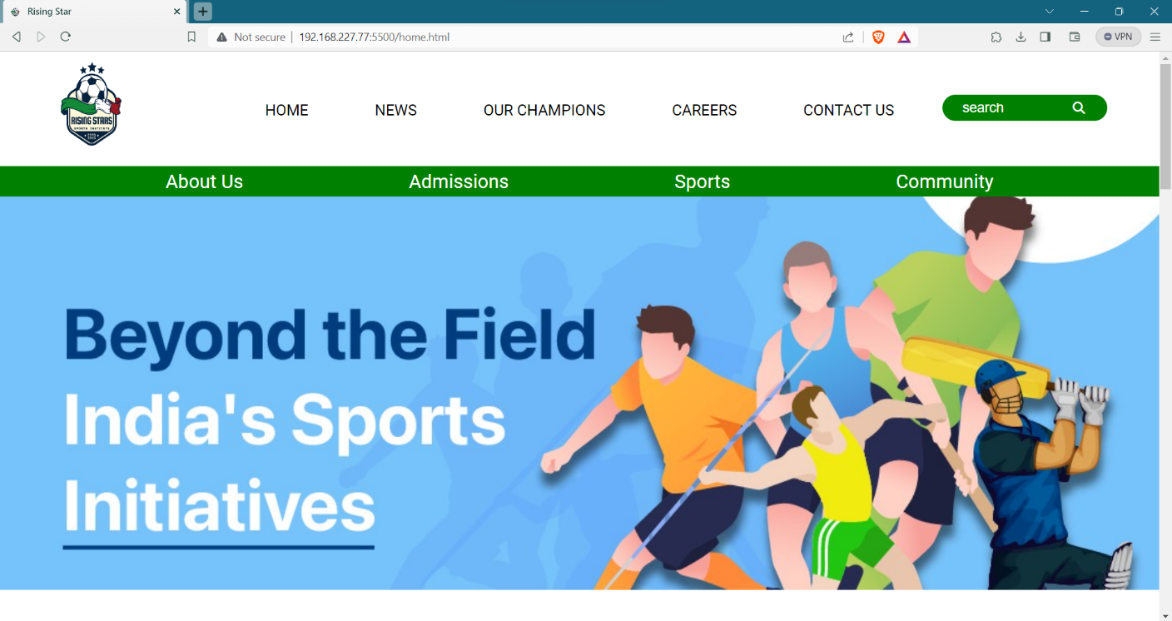

*Figure 3.1 Homepage – Navigation bar view*

This is the Homepage of the website; it contains navigation to all the other pages of the website. It contains Offers, Top deals and an impressive footer. The other part of this page are as follows:

**14**

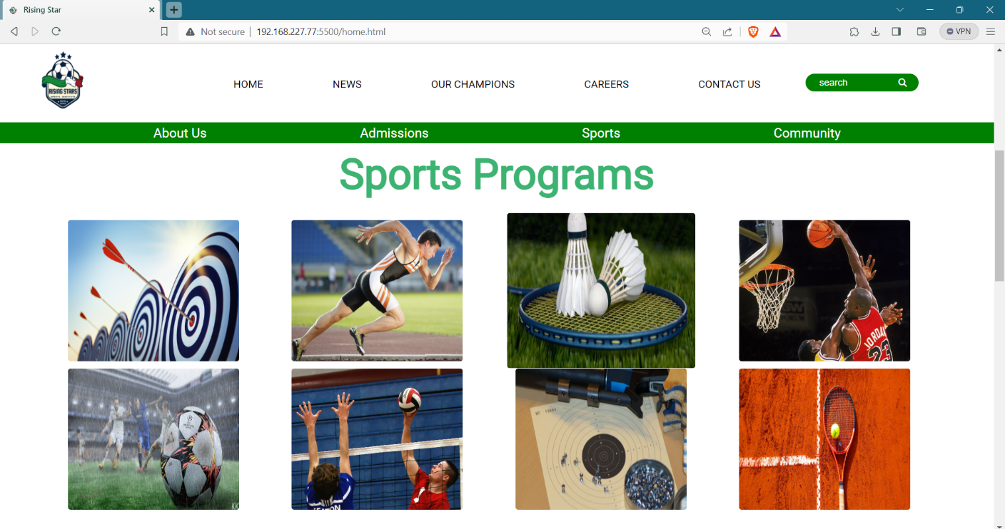

*Figure 3.2 Homepage- Different Sports Programs*

This part gives advertisement and information about different sports programs going on the website, to attract athletes and sportsperson. The Tiles shown here have Hover effect which makes it impressive and attractive. The homepage often features images of compassionate care, modern facilities, and testimonials, aiming to instill trust and confidence. It provides easy navigation, ensuring visitors can swiftly find the information they seek.

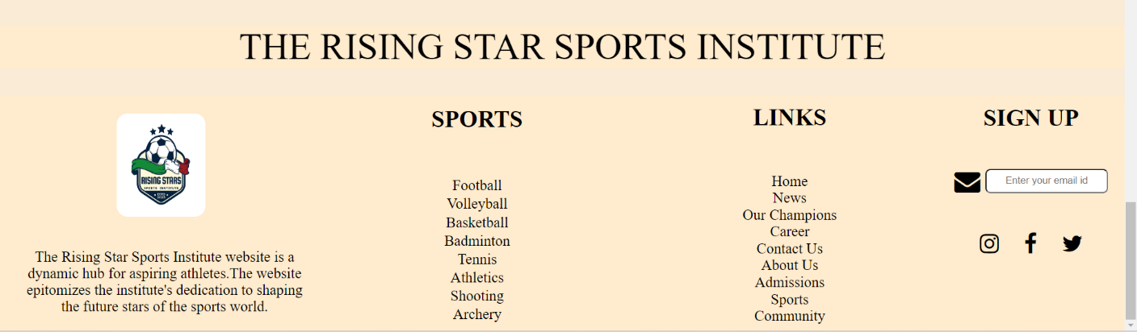

*Figure 3.3 Footer- Homepage*

**15**

**3.1.2 News Page**

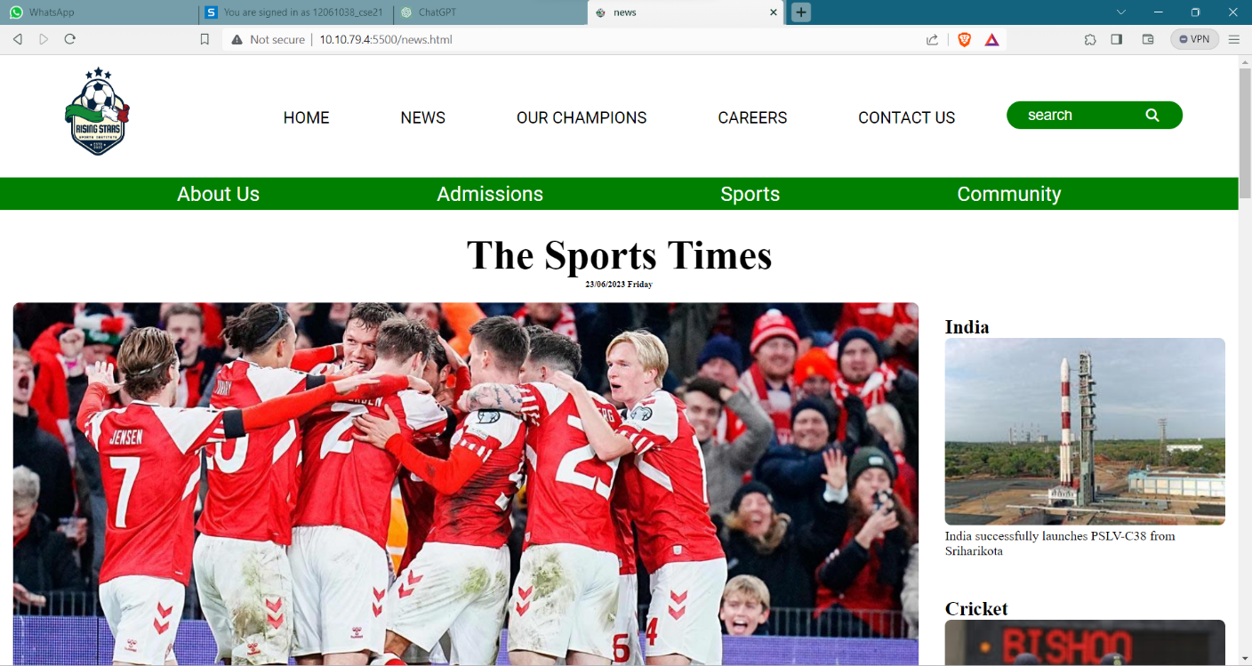

*Figure 3.4 News Page -Top container*

The News Page on the Rising Star Sports Institute Website is a dynamic source of real-time updates and achievements. It keeps users informed about upcoming events, workshops, and noteworthy athlete accomplishments. With regularly updated engaging content, the page offers a vibrant and informative insight into the institute's dynamic sports community.

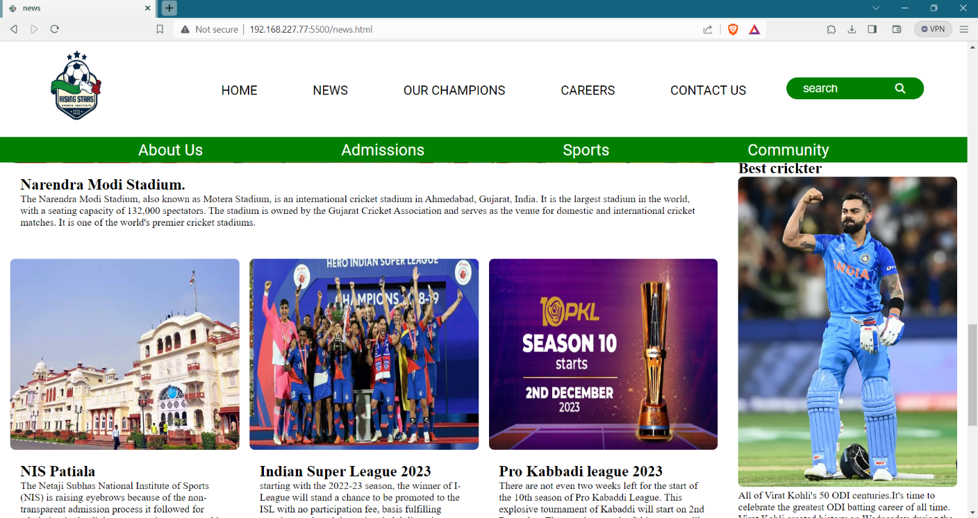

*Figure 3.5 News page – Body*

**16**

**3.1.3 Our Champions Page**

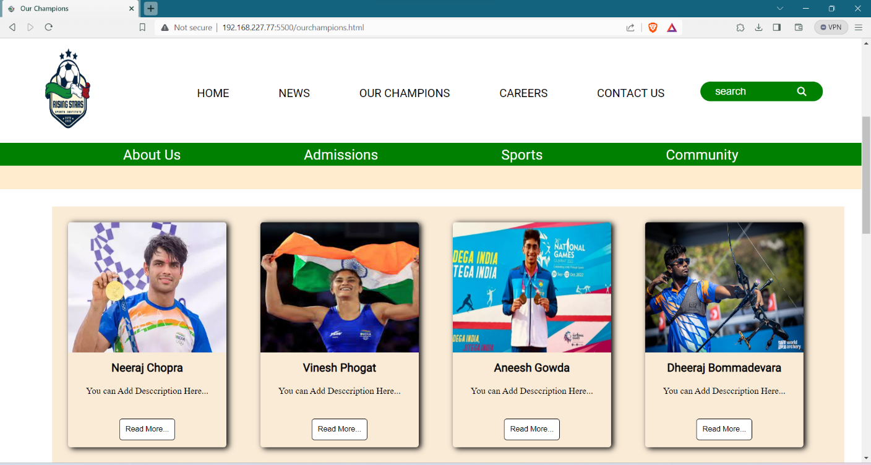

*Figure 3.5 Our Champions Cards*

Through captivating profiles and multimedia showcases, it offers a glimpse into the inspiring journeys and accomplishments of those who have excelled, creating a tapestry of motivation and pride within the sports community.

**3.1.4 Contact Us Page**

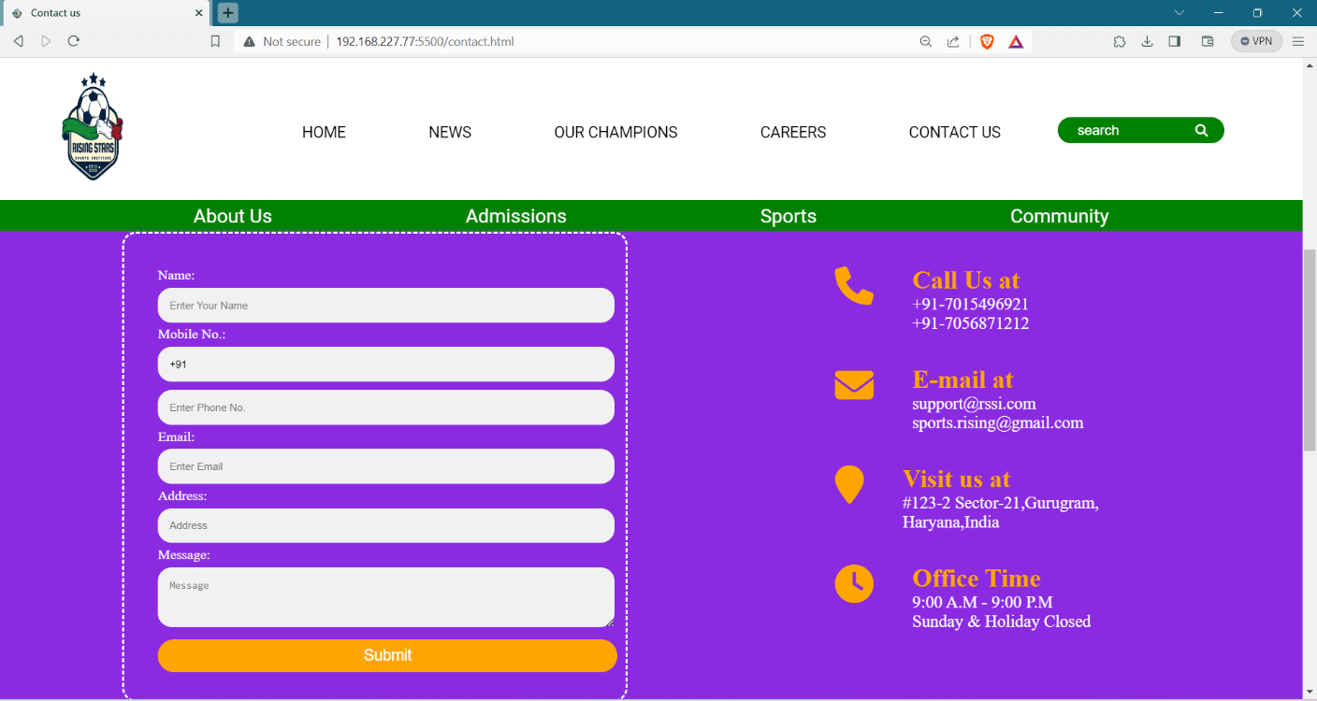

*Figure 3.6 Contact Us – Form and details*

**17**

**3.1.5 About Us**

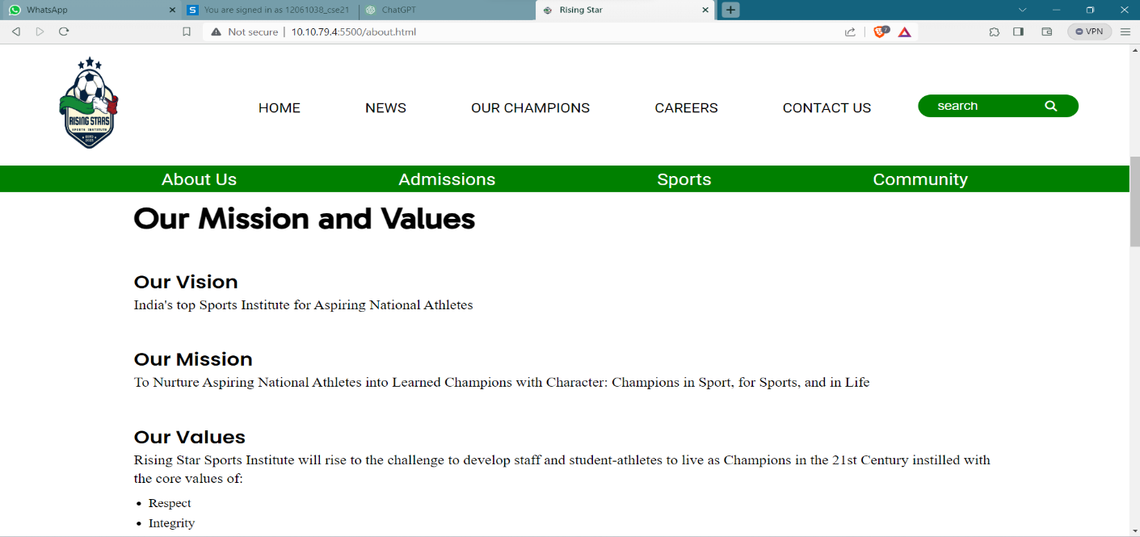

*Figure 3.7 About Us- description*

The About Us page on the Rising Star Sports Institute Website provides an in-depth exploration of our mission, values, and coaching staff. Engaging visuals complemented by YouTube video links offer an immersive experience, allowing users to connect with the institute's ethos, coaching team, and commitment to nurturing aspiring athletes.

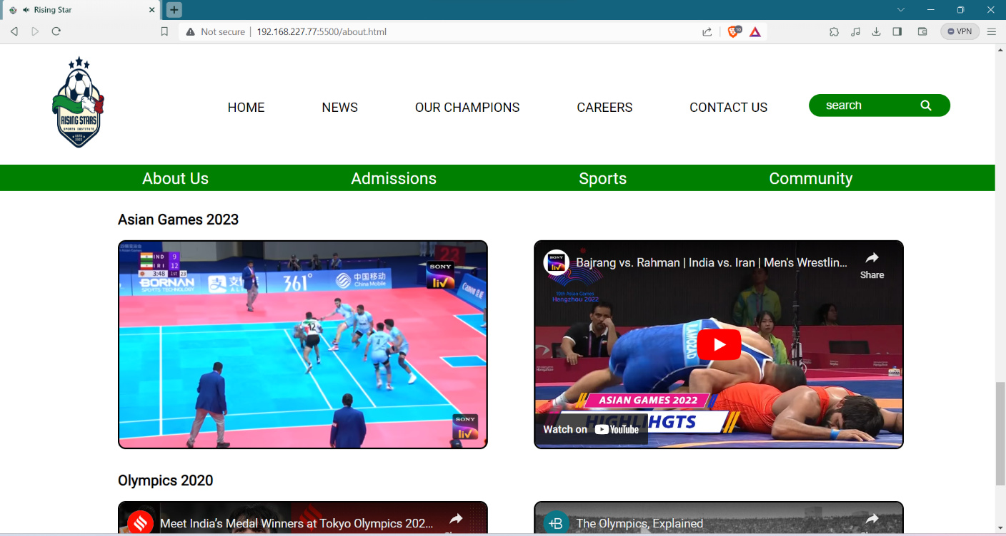

*Figure 3.8 About Us- YouTube Linked Videos*

**18**

**3.1.6 Admission Page**

The Online Admission Form page on the Rising Star Sports Institute Website streamlines enrolment with a user-friendly interface. It simplifies the admission process, offering easy access to detailed training programs, schedules, and multimedia content. The interactive JavaScript form ensures a hassle-free and convenient experience for prospective athletes, enhancing accessibility and enrolment efficiency.

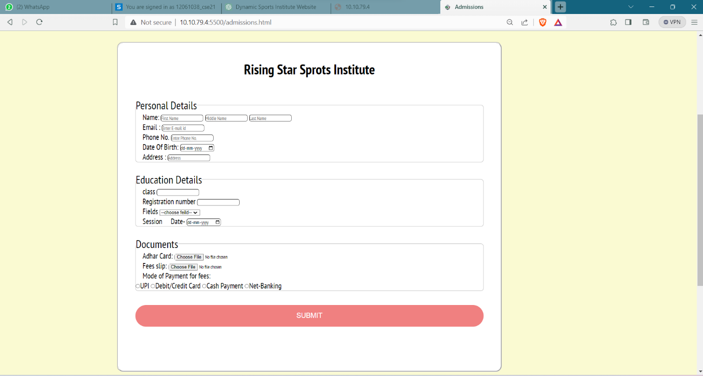

*Figure 3.9 Online Admission Form*

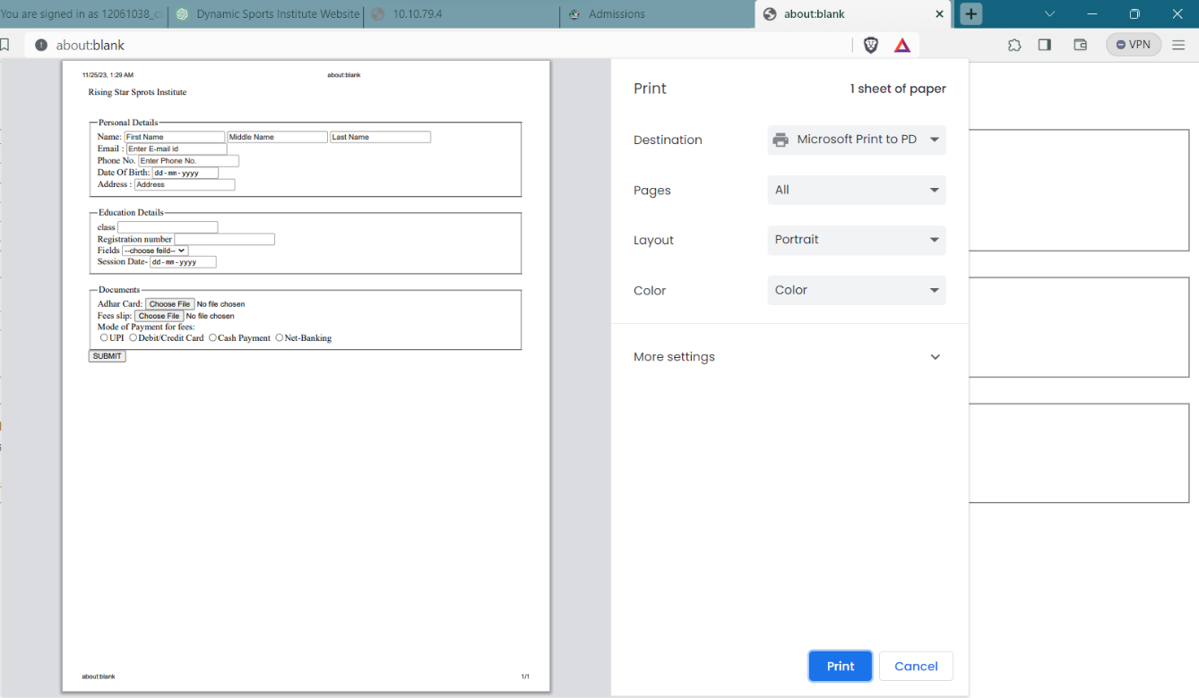

*Figure 3.10 Printed Receipt of Admission form*

**19**

**3.1.7 Sports Page**

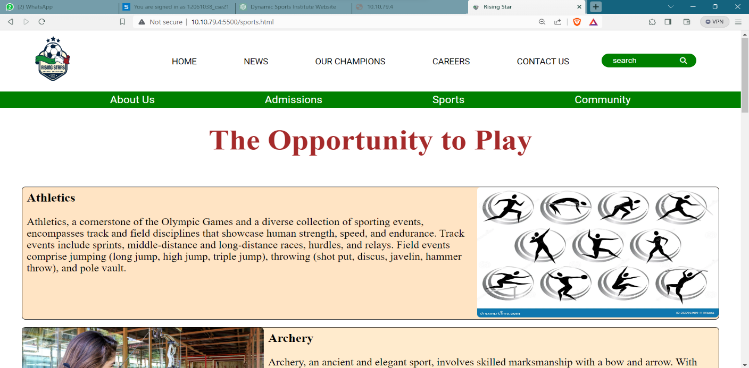

*Figure 3.11 Sports Page*

The Sports Page on the Rising Star Sports Institute Website is a comprehensive guide to our diverse training programs. With detailed information on various sports, captivating multimedia content.

**3.1.8 Our Community Page**

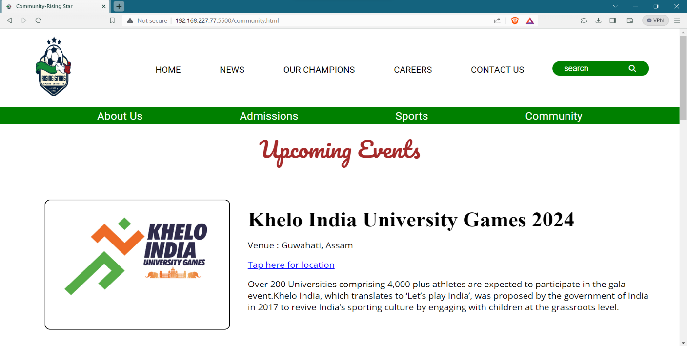

*Figure 3.12 Upcoming Events in Community Page*

This part of the page gives information regarding upcoming events to reach out community.

**20**

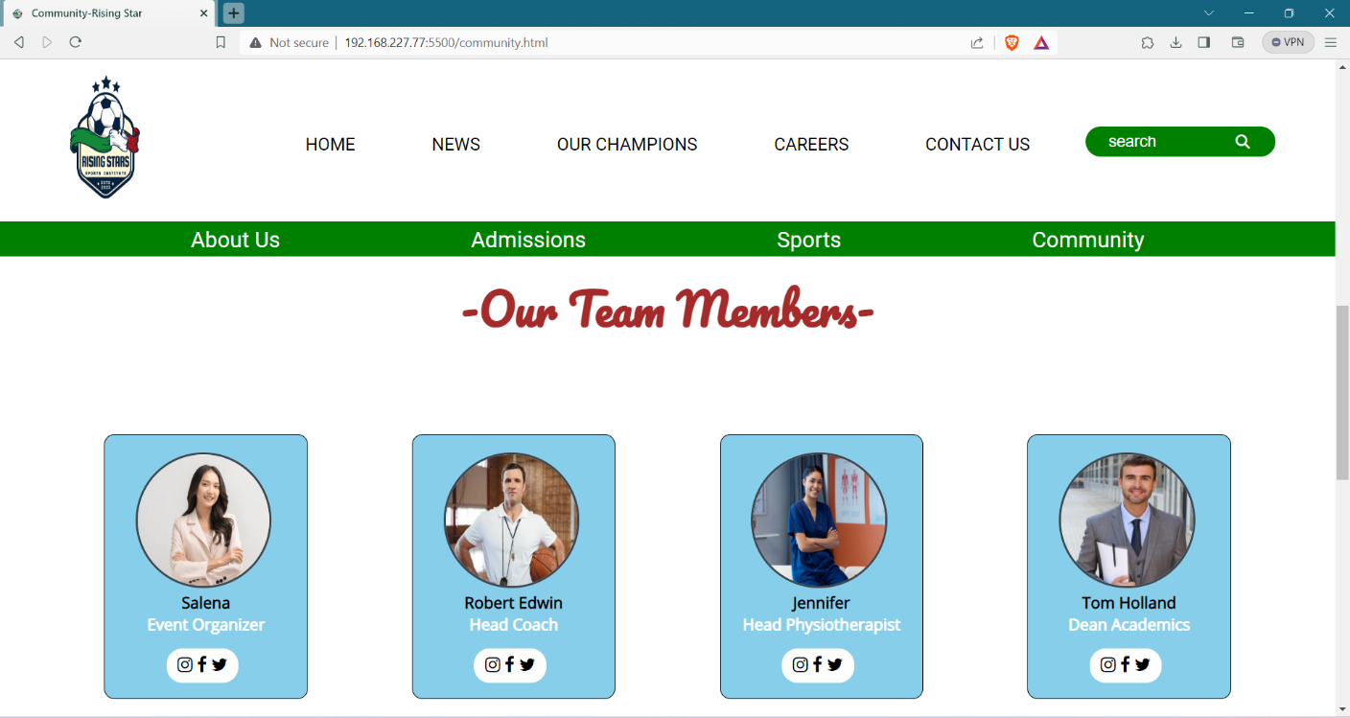

*Figure 3.13 Team Members- Community Page*

**21**

**CHAPTER – 4**

**CONCLUSION AND FUTURE SCOPE**

**4.1 CONCLUSION**

the Rising Star Sports Institute Website project has successfully achieved its objectives by employing a thoughtful combination of HTML, CSS, and JavaScript. The website is not just a digital presence but a dynamic platform that caters to the diverse needs of aspiring athletes and sports enthusiasts. The user-friendly interface and seamless navigation across key sections, including admissions, success stories, and sports programs, create an immersive online experience.

The incorporation of multimedia elements, such as images and videos, enhances engagement and provides a visual representation of the institute's ethos. The News Page acts as a real-time information hub, keeping stakeholders abreast of upcoming events, workshops, and athlete achievements. Moreover, the Our Champions section adds a personal touch, celebrating the individual journeys and successes of athletes, fostering a sense of community and inspiration.

The Key Features we have achieved are:

* **Comprehensive Information Hub:** The website serves as a central repository for information, offering details about training programs, facilities, and the institute's ethos.
* **Engaging User Interface:** The design prioritizes a user-friendly interface, ensuring easy navigation and accessibility for a diverse audience interested in sports education.
* **Interactive Features:** JavaScript is seamlessly integrated, providing interactive elements such as dynamic banners, event calendars, and multimedia galleries, enhancing user engagement.
* **Global Reach and Community Building:** Similar to the globalization seen in travel platforms, the website transcends geographical boundaries, fostering a global community of sports enthusiasts.

**22**

* **Security and Trust:** The emphasis on online security and data privacy, akin to travel booking websites, is evident through SSL certificates and secure payment gateways, instilling user confidence.
* **Inspiring Our Champions:** The Our Champions section celebrates athletes' successes through multimedia content, creating a tapestry of motivation and pride within the sports community.
* **Real-time Updates with News Page:** The dynamic News Page provides real-time updates on events, workshops, and achievements, ensuring stakeholders stay informed and engaged.

**4.2 FUTURE SCOPE**

The Rising Star Sports Institute Website project lays a solid foundation for future enhancements and expansions, opening up several avenues for further development and improvement. The future scope of this project includes:

* **Advanced Interactivity:** Implementing more sophisticated interactive features using evolving technologies to enhance user engagement and create a more immersive experience. This could include virtual training sessions, live streaming of events, or interactive coaching modules.
* **Personalized User Portals:** Developing personalized portals for athletes, coaches, and parents, providing tailored content, progress tracking, and communication channels. This could further enhance the user experience and strengthen the sense of community within the institute.
* **E-Learning Modules:** Integrating e-learning modules for athletes to access training materials, educational content, and skill development resources. This could expand the educational aspect of the institute beyond physical training sessions.

**23**

* **Integration with Wearable Technology:** Incorporating compatibility with wearable technology to monitor and track athletes' performance, health metrics, and training progress. This could provide real-time data for coaches and athletes to optimize training programs.
* **Expanded Multimedia Content:** Continuously enriching the multimedia content, including 360-degree virtual tours of facilities, live-streamed events, and high-quality promotional videos, to provide a more visually compelling and informative experience.
* **Mobile Application Development:** Creating a dedicated mobile application for convenient access to institute updates, training schedules, and community engagement. This would cater to the increasing trend of mobile usage among the target audience.
* **Integration with Social Media Platforms:** Strengthening the institute's social media presence and integrating social media feeds directly into the website. This would enhance connectivity and outreach, fostering a broader online community.
* **Data Analytics for Performance Evaluation:** Implementing data analytics tools to
* assess the performance of athletes, track trends, and make informed decisions for program improvements. This could contribute to the continuous refinement of training strategies.
* **Online Merchandise Store:** Introducing an online merchandise store to sell branded apparel, equipment, and merchandise related to the institute.
* **Multi-language Support:** Adding multi-language support to cater to a diverse international audience, facilitating broader accessibility and engagement.
* **Collaborations and Partnerships:** Exploring collaborations with sports organizations, educational institutions, and technology partners to enhance the institute's offerings, facilitate knowledge exchange, and broaden the scope of programs.

**24**

**REFERENCES**

* **Websites:**

1. w3school - <https://www.w3schools.com/>
2. SportsKeeda – <https://www.sportskeeda.com/>
3. JavaScript.info **-** <https://javascript.info/>

Importance: JavaScript.info is a comprehensive guide to JavaScript. It covers the language basics, DOM manipulation, and advanced concepts.

* **Online Sources:**

Websites like Udemy, Coursera, and freeCodeCamp offer courses on web development, including HTML, CSS, and JavaScript.

Importance: These platforms provide structured learning and can support your understanding of the technologies used in the project.

* **Magazine and News Articles:**

Articles from reputable travel and technology magazines or news outlets.